Why did the villager throw a spear at José ?

José went out in the forest and found 1 banana, 1 quetzal feather and 1 piece of obsidian. He figured that all of these were worth the same amount, so he offered the villager to trade 1 banana for his quetzal feather.

The villager got mad and threw his spear at José. Why on earth would he do that?

Let’s look at a graph that shows how many you found of each item on an average day.

Do you remember that a “distribution” is how things are divided?

You can have a distribution like this that shows the number of each item found in the forest on an average day.

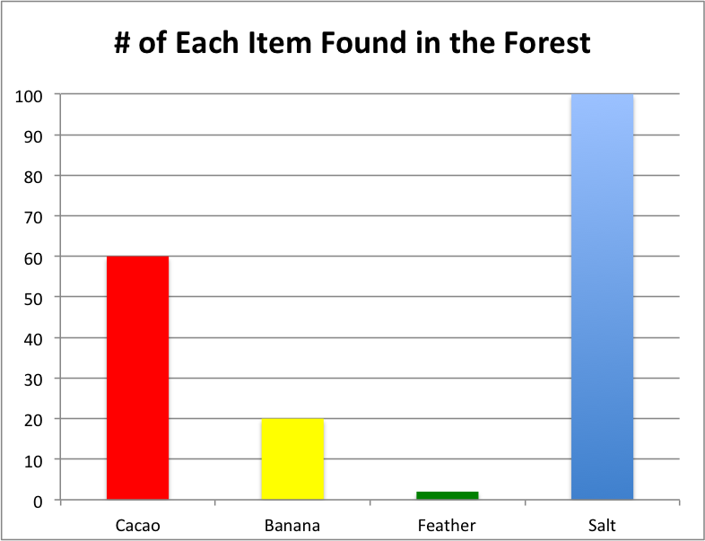

This distribution shows how the items you found were divided among the four categories, cacao beans, bananas, quetzal feathers and salt.

Another kind of distribution could show how often something occurs. Let’s say you went out in the rain forest looking for bananas on 11 different days. This table shows what you found:

DAY | Number of Bananas
May 1st | 25
May 2nd | 15
May 3rd | 1
May 4th | 39
May 5th | 20
May 6th | 20
May 7th | 18
May 8th | 22
May 9th | 20
May 10th | 18
May 11th | 22

You can look at the graph like this, but it doesn’t tell you very much except how many bananas you found on a particular day.

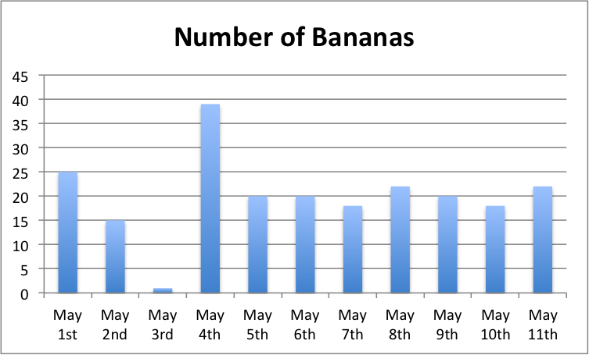

Here is how a mathematician would look at the distribution. First, make a table that shows how many days you found each number of bananas.

Bananas Found | Number of Days
1 | 1
15 | 1
18 | 2
20 | 3
22 | 2
25 | 1
39 | 1

When you graph this table, it is much easier to understand your distribution.

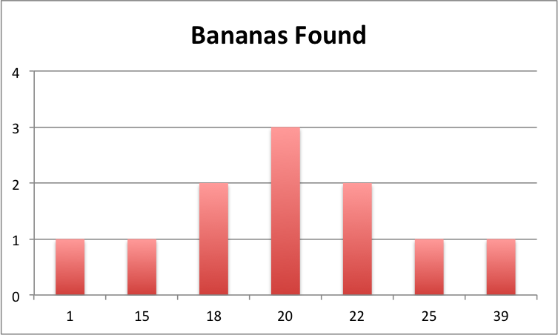

You can see three things right away:

1. There was only one day that you found less than 15 bananas.

2. There were only two days that you found less than 18 bananas. Another way of saying that is that on 9 out of the 11 days, or 82% of the time, you found 18 bananas or more.

3. The most common number of bananas found in a day is 20. On 3 days, you found 20 bananas.
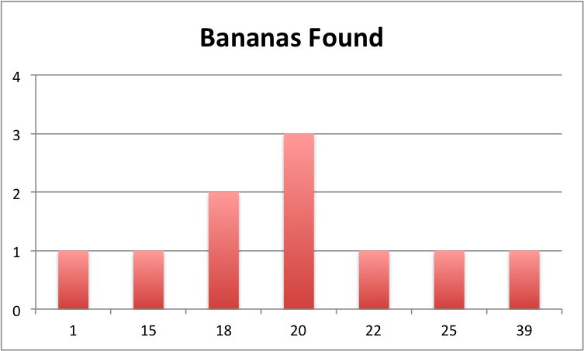

When we talk about the AVERAGE day, like the number of bananas that you can expect to find in an average day, that doesn’t mean you will find exactly 20 bananas every day.

Let’s find the average of our distribution of days of banana gathering.

Bananas Found | Number of Days
1 | 1
15 | 1
18 | 2
20 | 3
22 | 2
25 | 1
39 | 1

First, we find the number of bananas found, by multiplying the number of bananas by number of days we found that number and then adding that column

Bananas Found | Number of Days | Bananas x Days
1 | 1 | 1
15 | 1 | 15
18 | 2 | 36
20 | 3 | 60
22 | 2 | 44
25 | 1 | 25
39 | 1 | 39
TOTAL |  | 220

Second, we add up the number of days

Bananas Found | Number of Days | Bananas x Days
1 | 1 | 1
15 | 1 | 15
18 | 2 | 36
20 | 3 | 60
22 | 2 | 44
25 | 1 | 25
39 | 1 | 39
TOTAL | 11 | 220

Third, we divide the number of bananas by the number of days.

220 total bananas
------------------------ = 20 bananas average per day
11 days

If you didn’t know, now you know.

Another word for the average is the mean.

Still, why was the villager so angry with José ?

The answer is, because he thought José was trying to cheat him.

On that one day that he went into the forest, José found 1 quetzal feather and 1 banana, so he thought they were of equal value.

However, on the average, you would find 20 times as many bananas as quetzal feathers.

José missed the ideas of mean (or average) and variability (that data points in a distribution can be different from one another).

He’s lucky the spear from the villager missed him!

