Personal Support Network
Hi, it’s me, Angie, here with some good advice. I was thinking today about all the people that answered my survey in Crossroads: Options about support. Thanks, you are the best! Also, I got an A in my class in college, so thanks again.
I was thinking about what people said about who they had to support them and I think maybe some people don’t realize how much support there could be for them out in the community.
People who support you in positive changes don’t have to be your best friends and they don’t have to be people who would pay your rent or let you move into their house, although if you do have friends like that, lucky you. Part of your safety plan can be making a list of all of the people you could call for anything. Let’s take Jessie, for example. We’re cousins and I know her but not super well. If she wanted to quit hanging out with Dylan, and believe me, she should, there might be a night when she was really feeling lonesome and thought of calling him up.
There’s a saying that sometimes God sends your ex back into your life just to see if you’re still stupid.
Instead of calling Dylan, she could call me. When I’m staying at my dad’s, I’d be thrilled to hear from her – from, anybody, really. I don’t know anyone in the city he lives in and I’m bored watching YouTube videos all day. If I’m at my mom’s she could come over and watch a movie and eat popcorn. I’m not saying every day, but if she called me and said, “Hey, can I come over and hang out because I don’t want Dylan to think I’m home alone,” I’d say, “Sure.”
I was thinking of this and I made a People Map. Hey, don’t judge me. Inside are my grandma, my mom and my older sister, Ashley, because I can ask them for just about anything. If it was money 💰 to pay the rent, a ride to the store, someone to cry to about that guy I was with last year and then I found out he was going behind the gym and doing things with that – well, never mind, you get the idea.
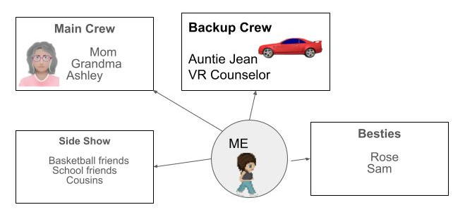

Then there are people who I call my backup crew. Like, Auntie Jean, who lives up in Canada. If I was really in trouble, she’d be there, like when my parents got divorced and I didn’t want to see either of them for a few weeks, she let me come stay with her. Or that time my car broke down and I didn’t have the money to fix it and I needed it to get to work. Did you know that the tribal vocational rehabilitation program will pay for car repair? My counselor, Rick, is cool, too. I can call him and talk to him about problems at work, too. Do you know how many times he has talked me out of walking out of that place? Sometimes, you just need someone to hear you out.
Then, there are my besties, Rose and Sam. Talk about people who will hear you out! Sam is my cousin, too. While my other cousins are okay, I see them maybe once a month. Sam has been in the same grade with me since kindergarten. We live in the same town. Our moms are sisters. He basically knows everything about me and when he heard about that guy we aren’t mentioning, he went over there and told him if he ever talked to me again or came near my house – well, he just better not do it. Rose has lived next to me since I can remember, and we have been friends just as long. If I’m having a bad day, she always has a joke and is ready to hear me out.
Then, there is the side crew. These are the people I know from basketball or school. If I am feeling a little down and just want to talk to someone about nothing important or get up and get some exercise, they are good for that. I can call them and get a homework assignment I missed in class.
Sometimes people disappoint me because I think they are in one spot as support and it turns out they’re not. And sometimes people surprise me.
Try making your own people map
First, my mom says it’s called a “Personal Support Network.” Whatever. 🙄
My grandma says you should always think about what you should do in a situation before you must deal with it. She says that is why soldiers have basic training. They don’t end up in a war and wonder which end of the rifle to shoot with. Did I tell you my grandma joined the army when she was 18? How badass is that? My coach says we have practice because we don’t make up strategy on the court.

Visit StrongMindStrongBody.org for apps and further resources.

